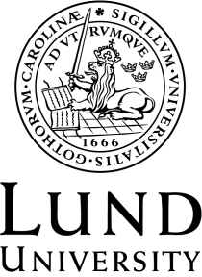

Department of Communication and Media

SCHEDULE Autumn 2019
MKVN13 Media and Diversity, 15 credits
Course leaders: Deniz Duru and Tobias Linné
Teachers:
DD: Deniz Duru
TL: Tobias Linné

Date | Time | Room | Teaching | Teacher
Monday 4 Nov | 10-12 | H140 | Introduction  Lecture | DD/TL
Tuesday 5 Nov | 13-15 | A129b | Lecture 1
Thursday 7 Nov | 10-12  13-15 | H435  H140 | Workshop
Monday 11 Nov | 13-15 | L207 | Lecture 2
Thursday 14 Nov | 10-12  13-15 | L201  A129b | Workshop
Monday 18 Nov | 13-15 | A121 | Lecture 3
Thursday 21 Nov | 10-12  13-15 | H140  H140 | Workshop
Monday 25 Nov | 13-15 | L201 | Lecture 4
Thursday 28 Nov | 10-12  13-15 | H140  H140 | Workshop
Monday 2 Dec | 13-15 | H239a | Lecture 5
Tuesday 3 Dec | 10-12  13-15 | H135a+H135b  H135a+L503 | Workshop
Thursday 5 Dec | 10-12 | A129b | Fieldwork workshop
Friday 6 Dec |  |  | Fieldwork
Monday 9 Dec | 10-12 | L201 | Seminar
Tuesday 10 Dec | 13-15 | H140+H239a | Workshop
Monday 16 Dec | 13-15 | H140+H135b | Seminar
Tuesday 17 Dec | 13-15 | H140+H135a | Seminar
Wednesday 18 december | 13-15 | To be confirmed | Diversity Event
Tuesday 7 Jan | 13-15 | H140+H135a | Workshop
Wednesday 8 Jan | 13-15 | H140+H135b | Seminar
Thursday 9 Jan | 13-15 | H140+H135b | Workshop
Friday 17 Jan | 12.00 | Deadline for essay submission | Course platform

